**Importing one package to another package or functions from one module to another module :**

* Better to use “Visual studio code” for better understanding

**Our objective:**

* Our aim is to import the one package from another package or calling the functions from one module to another module, like calling the functions in **course_details.py** from **payment_details.py** or vice versa

**Package**: It is a directory (folder) to hold all the modules in it.

**Ex:** From the above screenshot, we can conclude that the “Course” and “Payment” are the packages and the “course_details.py” and “payment_details.py” are the **modules**

**We can create ‘n’ number of modules in one package and similarly We can create ‘n’ number of functions in one module**

(Simply it is like “numpy” is the package, “arange” is the module in the numpy package

**Ex:** np.arange(0,10) )

The content in the both modules as follows:

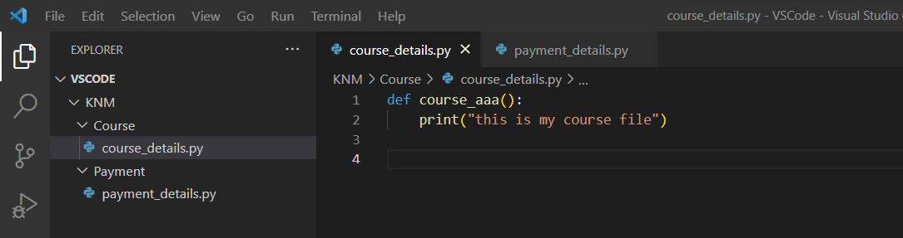

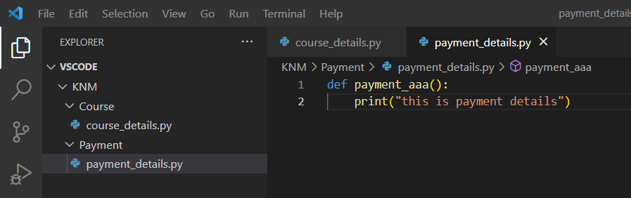

Let’s start importing modules from one package to another package

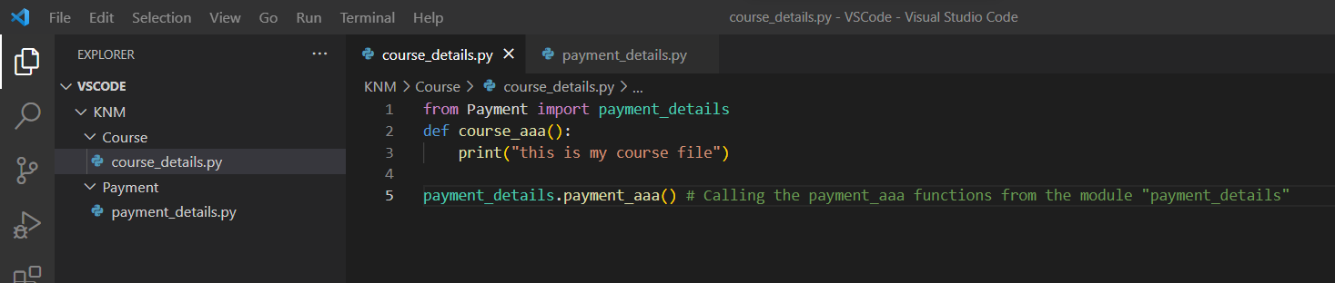

Here we have used the syntax like from <package_name> import <module>

**Ex:** from numpy import arange

**>>** from **Payment** import **payment_details**

But we are getting the error while importing the modules even though we have a module “payment_details” because the module “payment_details.py” is a untracked file.



* In our system, the payment_details.py module is under multiple folders, Because of that reason Course package won’t able to locate the payment_details.py in the system. To Limit the error, we have to import some packages to create a cache and to collapse the folders so that “Course” package will be able to locate the file.

**Code for creating cache and collapsing all the folders:**

import os,sys

from os.path import dirname,join,abspath

sys.path.insert(0,abspath(join(dirname(__file__),".."))) # To create cache and to collapse the folders

cache created:

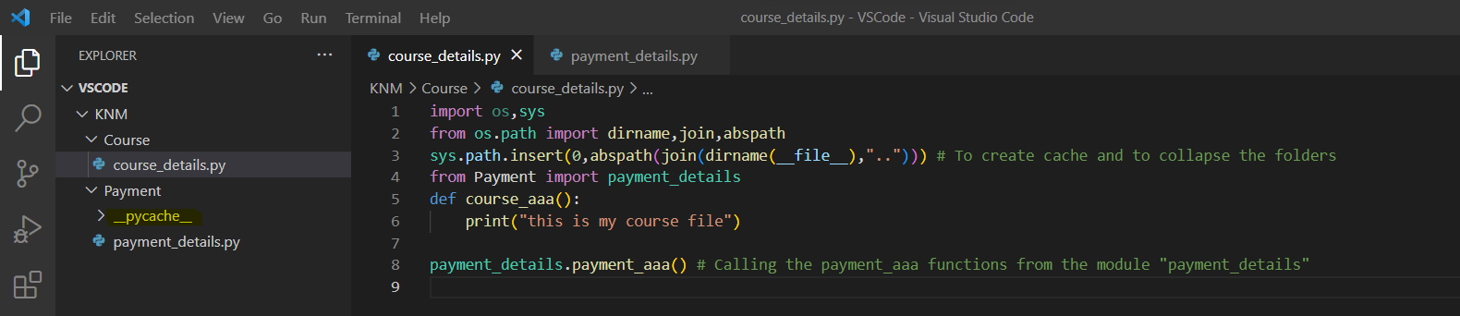

code in “**course_details.py”**:

import os,sys

from os.path import dirname,join,abspath

sys.path.insert(0,abspath(join(dirname(__file__),".."))) # To create cache and to collapse the folders

from Payment import payment_details

def course_aaa():

    print("this is my course file")

payment_details.payment_aaa() # Calling the payment_aaa functions from the module "payment_details"

Code in Payment package:

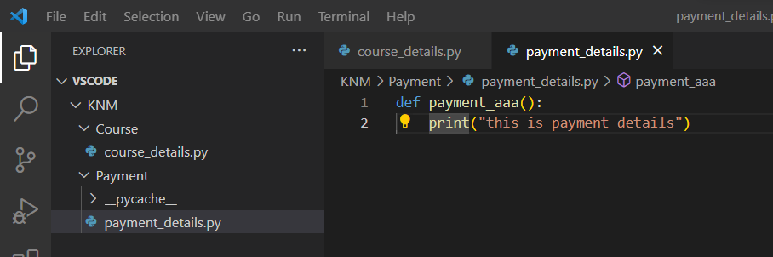

**Output of the code:** <we are successfully called **payment_aaa** function from **course_details.py** package >

